TASK MANAGING SYSTEM

1.After I had completed the backened and frontend code in VS Code by using React.js, MongoDB, Express.js and Node.js, I had opened the split terminal of VS Code which looked like this:

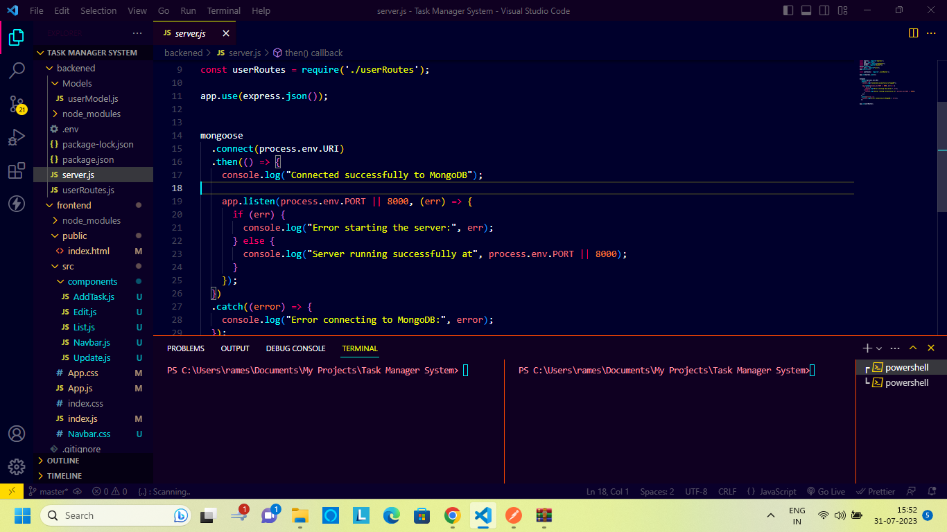

2. Then with the command "cd backened" and "cd frontend" we can be inside the respective backened and frontend folders as shown below:

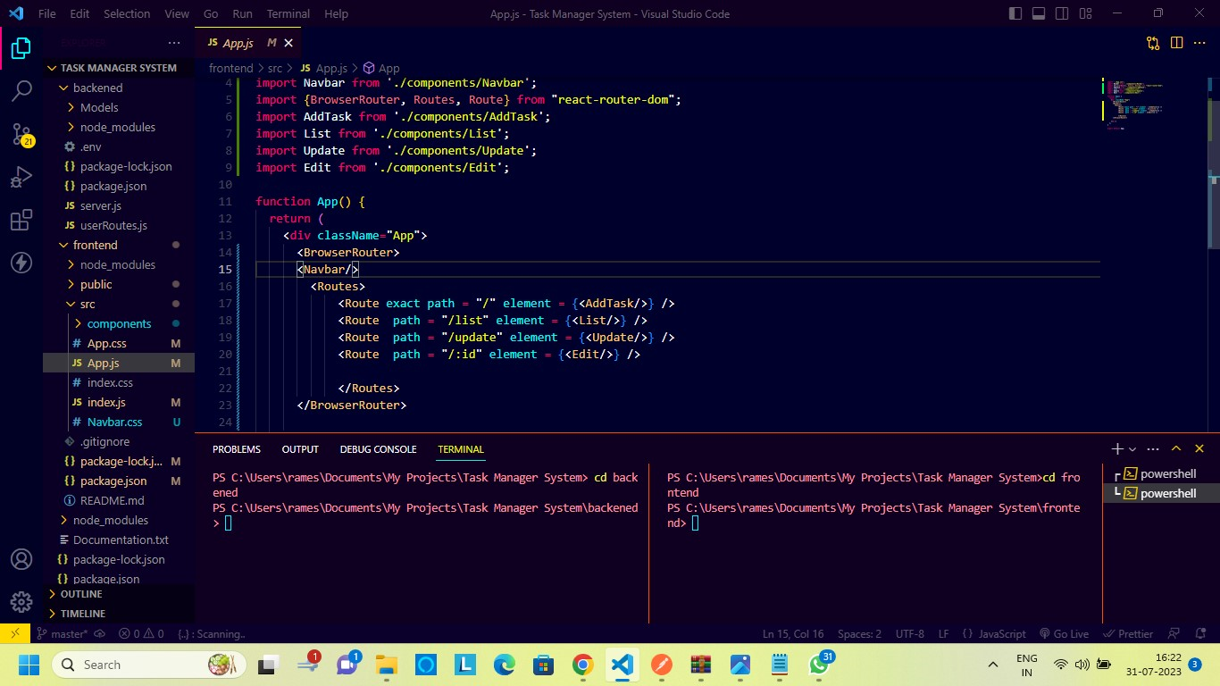

3. Then on one side of the split terminal I had started the backened part and on the other side I had started the frontend part as shown below:

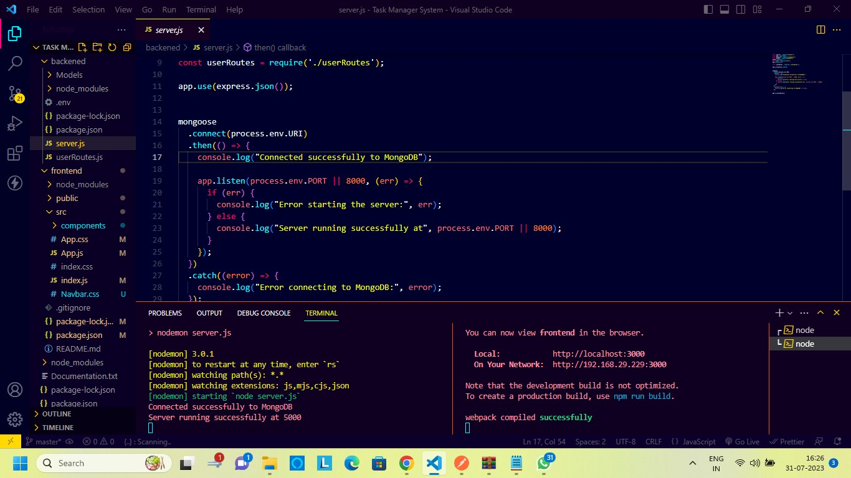

4. My backened part is running on "http://localhost:5000/". It shows all the data that is being added to the database as shown:

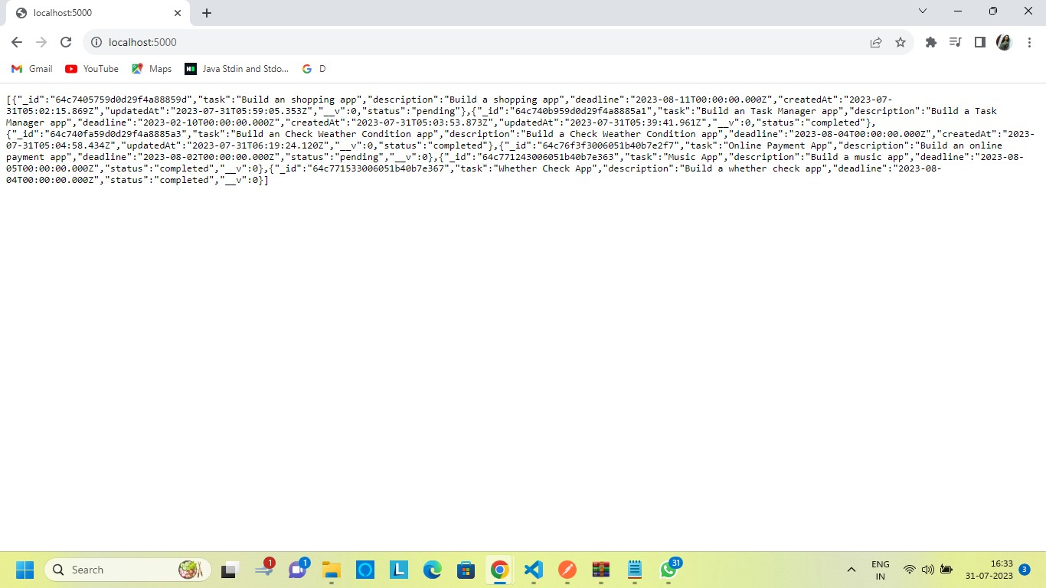

5. My frontend part runs on "http://localhost:3000/". It displays the following page:

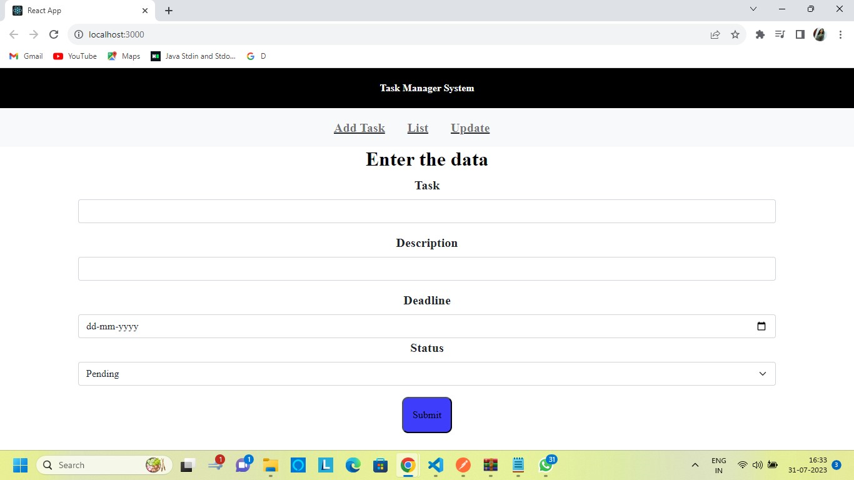

6. When I add data in the frontend part on the Add Task Page and press the submit button, the List page appears which displays all the data in the following way:

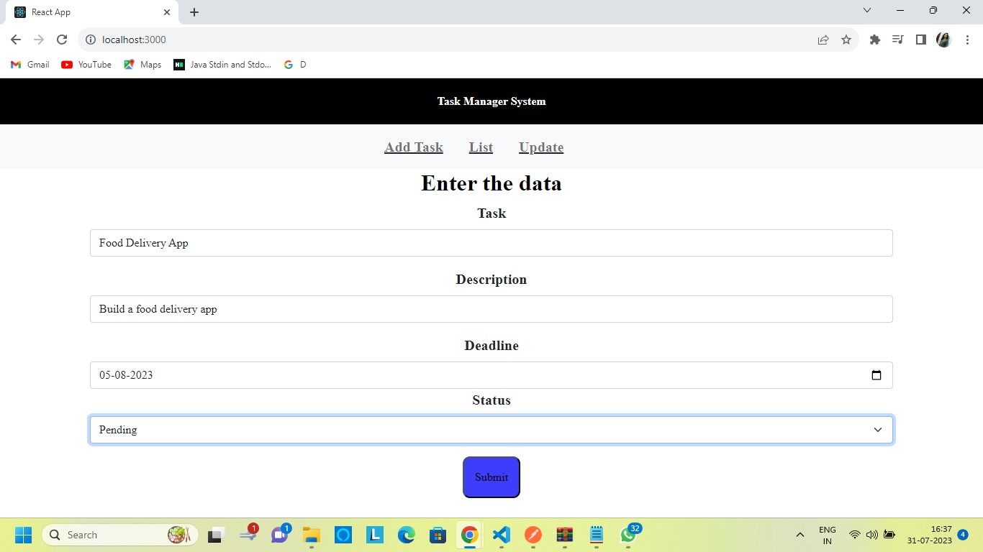

List Page:

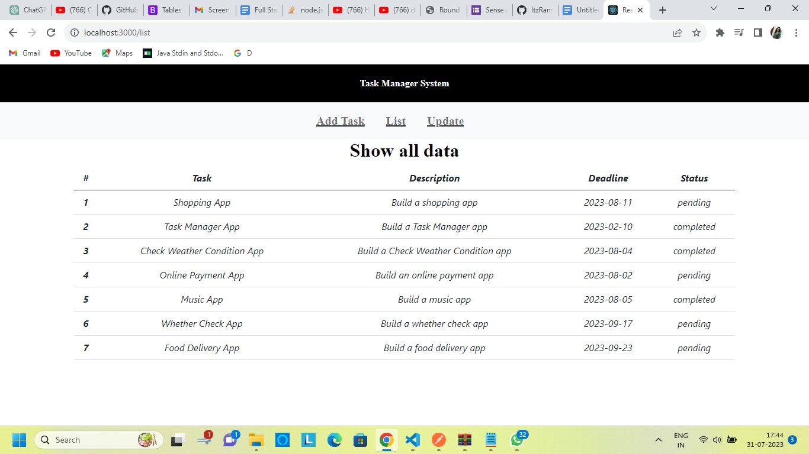

7. To update the data I clicked the on the Update and the following page gets displayed:

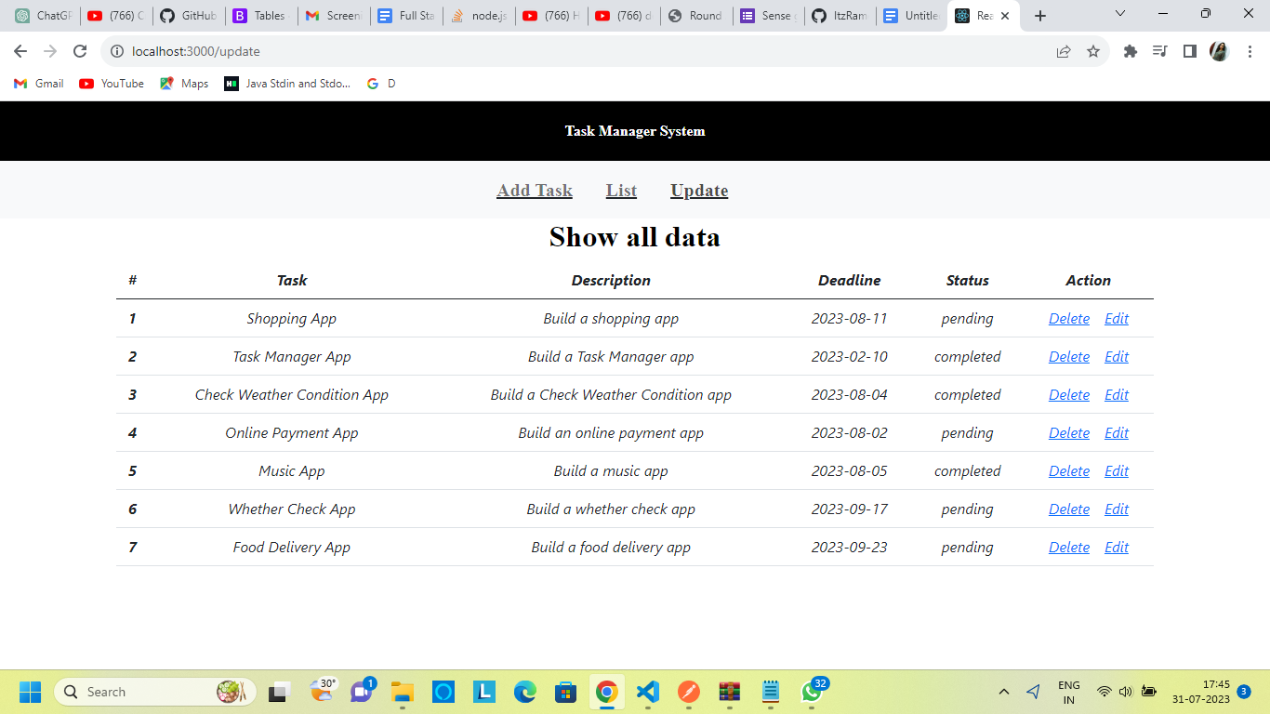

8. When I click on delete a message appears on the screen and then the data disappears as follows:

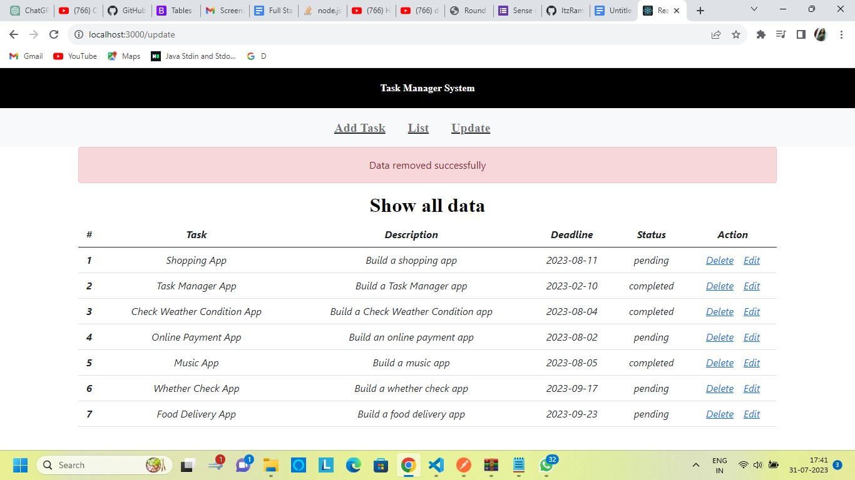

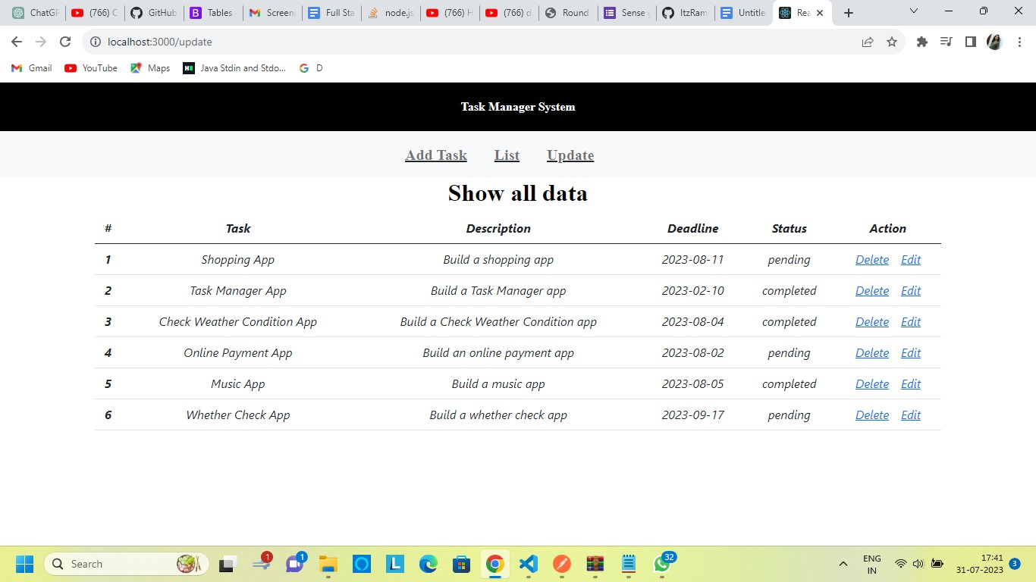

9. Then I click on the edit option and the following page appears:

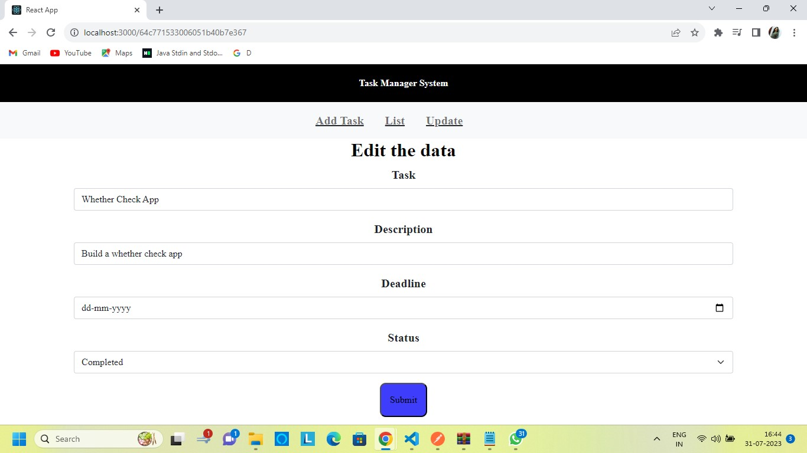

10. Then when we update and click on the submit button :

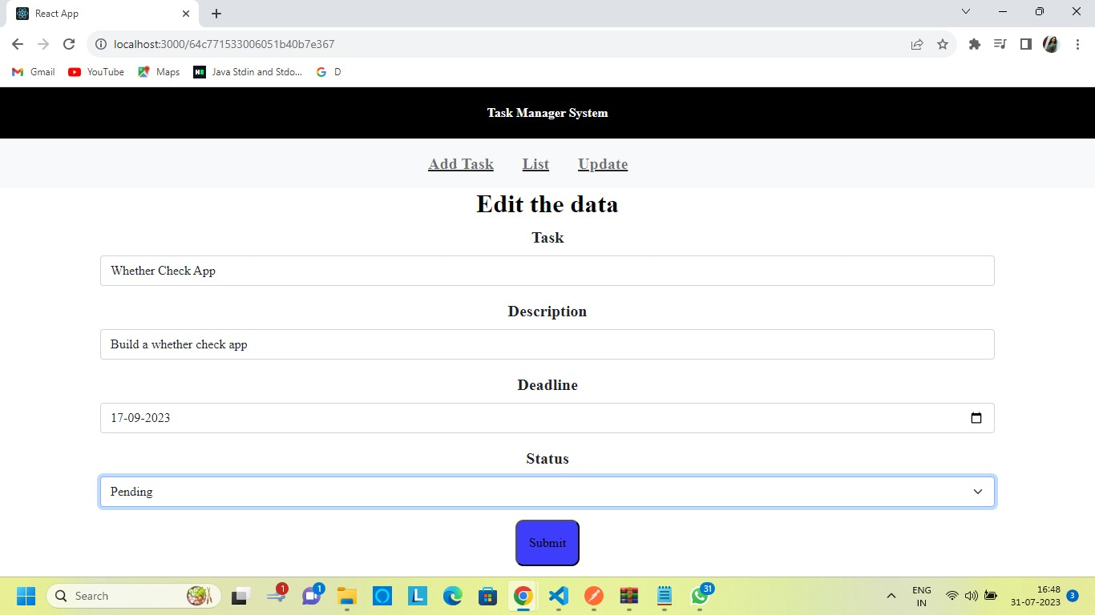

11. The following page appears:

